Chapter 7: Posting a Web Site Within an Hour (or So)
Easy Web Design, Chapter 8, pages 178-184

Planning an MSN Space
Planning your site is your first task in any Web publishing endeavor—even when you’re using a blogging service such as MSN Spaces. Generally, blogging services—MSN Spaces included—simplify the planning process by providing layout templates, themes, and other Web page creation resources and utilities. MSN Spaces offers a number of helpful tools, most notably themes, modules, and layout options.
note Many people find the themes, layout, and content modules helpful when they create their MSN Spaces. Others might be frustrated by the limited amount of customization available. Most notably, at the time this book was written, MSN Spaces members can’t modify their sites’ Hypertext Markup Language (HTML) code or apply custom color schemes or background images. If your goal is to create a blog and get information online quickly and for free, the minor design limitations shouldn’t be showstoppers for you. With any luck, MSN will continue to evolve and grant a greater level of design options.
On the MSN Spaces site, you create a blog by:
- Signing up with MSN Spaces.
- Choosing a theme.
- Selecting and positioning content modules.
- Selecting a basic layout.
- Configuring settings.
- Providing content.
That might sound like a lot, but it’s really not. If you’ve worked your way to Chapter 7 in the Easy Web Design book, setting up a Web site from predefined options is a good “next step” in your progression toward Web site mastery.
Because we opted to work with MSN Spaces, our planning process for Chapter 7’s Web site didn’t require a framework or storyboard pages. Instead, the planning process involved defining what features should be included on the site to get started. For example, we opted to start with the following content modules:
- Profile
- Blog
- Photo Album
- Favorite Web Sites (custom list)
- Schedule (custom list)
- Archives

note Just to gain a little practice in storyboarding, you might want to sketch your MSN Space after you understand how MSN Spaces uses column layouts and content modules.
Also, during the planning stages, we learned that our fictional client is the leader of a night watch crew. He wanted a site that could be quickly updated and provide a home base for crew members. He also wanted the site to have a nighttime security feel to it. As you’ll see later, we selected a theme that has a bit of a night vision look.
To summarize, the planning process incorporated the following simple steps:
- Determine the information to be displayed
- Select the appropriate content modules to be included
- Select a theme and layout
- Gather a few graphics
note You don’t necessarily need to gather graphics to get started with an MSN Space. Using MSN Spaces, you can easily add and delete graphics after you’ve created your blog. Remember, you can use this walkthrough project’s pictures or MSN clip art for now, and then you can delete the temporary pictures (or delete your practice blog altogether) and insert your own images whenever you have digitized pictures ready for online viewing.
You can re-create the fictional site using the graphics we provide for this walkthrough, or you can follow along using your own content and design decisions. The instructions for this project can be easily customized to create any MSN Space. Our goal is to get you off on the right foot—where you wander during the process is up to you.
Now that a general plan for the MSN Spaces site is in place, it’s time to sign up to become an MSN Spaces member. But first, do you have your passport?

Obtaining Your Microsoft .NET Passport
Universally, free blogging services and online communities require you to join their sites. Joining usually involves completing an online form that seals your membership. Becoming a member serves a number of purposes, including providing security options that control who can access your blog, creating your Web address, and configuring other custom settings. To use MSN Spaces, you must sign up for a .NET Passport. As you’ll see in a moment, obtaining a passport doesn’t require you to divulge any savings account numbers, credit card PIN passwords, or other sensitive information. In fact, the process is fairly innocuous.
If you own a free Hotmail e-mail account (available at www.hotmail.com), you can use your Hotmail information as your .NET Passport. If you don’t have a Hotmail account, you’ll need to obtain a .NET Passport. Here’s how:
- Click the Microsoft Passport Network link on the MSN Spaces home page (spaces.msn.com), or visit www.passport.com.
- Read through the information provided on the Microsoft Passport Network page, and then scroll to the Sign Up Today area. Decide whether you want to sign up for a new Hotmail account (this process is more involved than using your own e-mail address) or create a passport using your existing e-mail address (we recommend this approach), and then click the corresponding Get Started Now link. You’ll see a blank Create Credentials form, similar to the one shown in the figure.
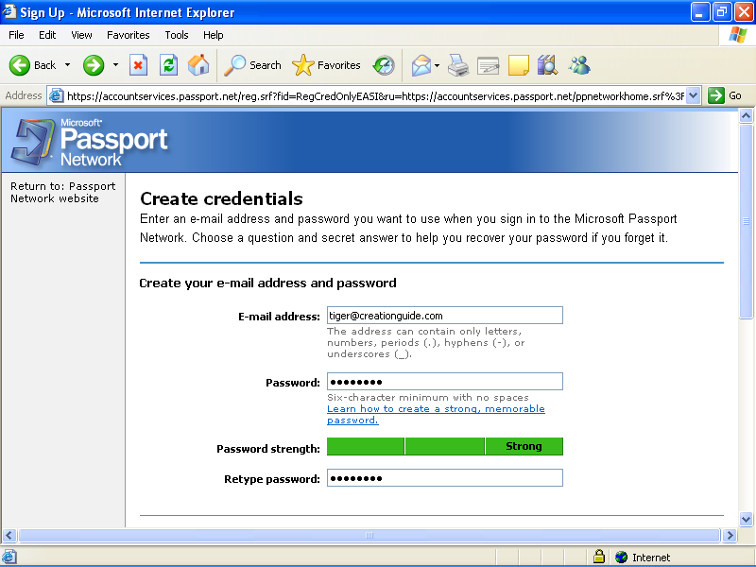
The Passport registration form, containing e-mail address and password information
- To complete the Create Credentials form, you must first enter your e-mail address in the standard username@domainname.abc format (for example, mm@creationguide.com). Keep in mind that you must enter a legitimate e-mail address before Microsoft will grant you .NET Passport privileges.
- In the Password field, enter a strong password. A strong password is from 7 to 16 characters long (even though you can use a 6 character password) and uses uppercase and lowercase letters, numerals, and symbols. For example, 100%Safe is considered a strong password, although we don’t recommend that you use that password since it’s now published online! The Password Strength meter on the Create Credentials form indicates whether your password is Weak (red), Medium (orange), or Strong (green). The password entered in the preceding figure is rated Strong.
- After you specify an easy-to-remember yet strong password, retype it in the Retype Password box.
- Even though you probably just chose a password that’s easy to remember, Microsoft provides a question-and-answer backup system to compensate for human nature—after all, everyone knows the feeling of forgetting a name immediately after an introduction or wandering around a parking lot before recalling where you parked the car. Select a question in the Question drop-down list, and then type your secret answer. If you forget your password, you can answer the question to gain permission to reset your password.
- At this point, you’ll see a picture containing oddly shaped characters. All you need to do is type the characters you see in the picture. This step ensures that you are a real person and not an automated program trying to sign up for a Passport account. In most cases, automated programs cannot differentiate the letters and numbers in the picture.
- Click Continue.
- Review and then print the agreements, enter your e-mail address in the text box, click I Accept, and then click Continue.
- Last, open your e-mail application and check for new messages. You should receive two e-mail messages. One is a welcome letter from Microsoft Passport. The other message is a confirmation message. Open the confirmation message, and click the link in the message to confirm your new Passport account.
Congratulations! You’re now officially registered and signed in as a Microsoft .NET Passport holder. Most importantly, you’re ready to create your own MSN Space.

Creating an MSN Space
As mentioned in an earlier section, this sample walkthrough’s steps result in an MSN Space developed for a fictional client. Our client is the leader of a night watch crew, and his code name is Phat Tiger. We encourage you to use your own information. If you don’t like your results by the end of this chapter, you can always delete content, delete modules, or delete the entire MSN Space and start over from scratch.
Here are the steps to set up a new MSN Space:
- Display the MSN Spaces home page (spaces.msn.com) in your browser window. Ideally, you should use Microsoft Internet Explorer version 6 or later when creating an MSN Space.
- On the MSN Spaces home page, click Sign In, enter your e-mail address and password, and click the Sign In button again. The Create Your Space form is displayed. The following figure shows the form completed with sample text.
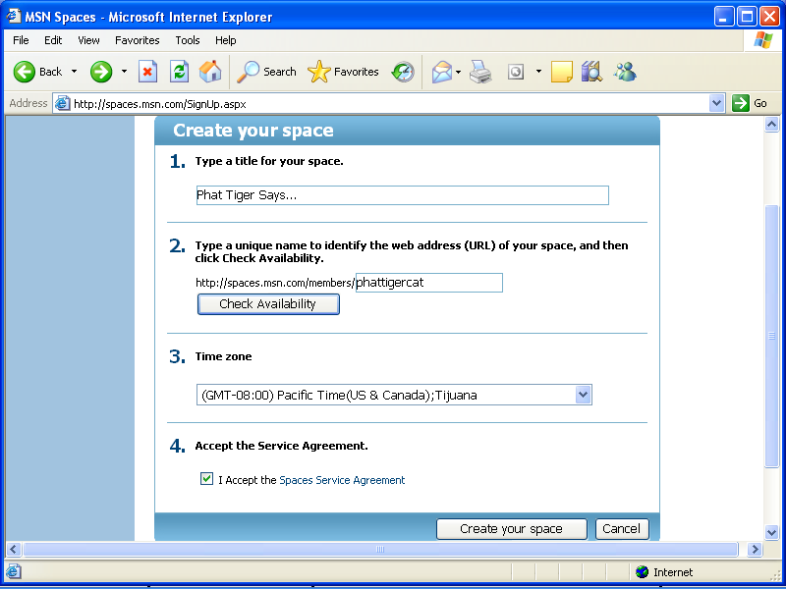
The Create Your Space form with sample text
- To complete the form, type a title that will appear at the top of your MSN Space, type a space name to create a Web address, and then click Check Availability to verify whether you can use the Web address.
- After your Web address is set, select your time zone, read and accept the Spaces Service Agreement, and then click Create Your Space.
- The Congratulations screen displays your new Web address, indicates that your settings are set to Messenger (which means only people on your MSN Messenger contacts list can see your space), and provides a link to the MSN Spaces code of conduct. You can change your permissions settings later, so click Go To Your Space to get started. You should see a generic blue-themed MSN Space preconfigured with default content modules, as shown in the following figure.
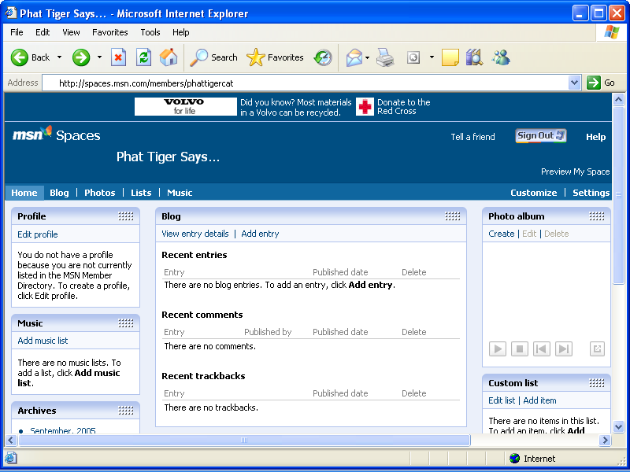
Viewing a new MSN Space
- You’ll also receive a Welcome to MSN Spaces e-mail message confirming your MSN Space’s Web address. You can click the Web address link in the e-mail message to view your newly created blog.
There you go! You have an MSN Space, and it’s officially online. Next you need to customize your space and provide some content.

Customizing Your MSN Space
Now that you’ve carved out a space for yourself online, you should spend some time customizing your domain. After you create your space, you can sign in with your .NET Passport and edit your space at any time by clicking the Sign In button in the top-right corner of your MSN Space.
After you sign in, MSN offers Customize and Settings views. If you click Customize, the Customize option appears selected near the right side of the screen. If you shift your eyes left across the page from the Customize option, you’ll notice Themes, Modules, and Layout menus. The next few sections in this walkthrough take a look at those options. They are your keys to customizing your MSN Space’s design and content. Let’s start by choosing a theme and a layout for the MSN Space.
tip After you create an MSN Space, you must always be signed in with your .NET Passport information before you can make any changes. To sign in, click the Sign In button, which appears on every MSN Spaces page.

Choosing a Theme and a Layout
MSN Spaces allows you to designate a theme and a layout. A theme consists of a collection of colors, fonts, and images used to display your space. Currently, you can choose from over 80 themes. In contrast, a layout simply indicates the number and size of columns and rows in your MSN Space. By default, your space uses three columns.
lingo In the context of MSN Spaces, a theme controls a space’s colors, fonts, and background, whereas a layout controls the number of columns and rows in the space’s content area.
To choose a theme, click the Theme menu, and then click a theme thumbnail image. (Notice that there are two pages of theme options.) When you click a theme option, your space displays the theme’s settings. You can change the theme as many times as you want. Your selection doesn’t become permanent until you save your changes (but even then, you can change your theme any time you’re in edit view).
For the Phat Tiger Says… space, we selected the second color on page two. The black-and-green theme reminded us of night vision imagery we’ve seen in news stories, and since the MSN Space is for a night watch crew, the association made sense. If possible, you should choose a theme that reflects the purpose or personality you want to convey with your space.
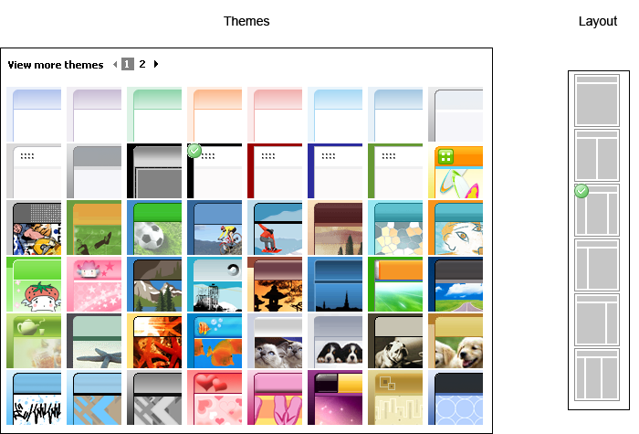
The Themes and Layout options for MSN Spaces

To choose a layout for your MSN Space, click the Layout button and select your column preference. For this project, we stuck with the default three-column approach (the third option on the Layout menu). A three-column layout with the center column representing the largest content area is a standard and useful layout employed by many bloggers and Web designers.
You can experiment with different layout options, but be prepared—when you change layout settings, your content modules are automatically resized and reorganized into the new layout selection. If you revert to the three-column layout after experimenting, you might need to reposition your content modules. Of course, repositioning modules isn’t a big deal, since you can drag modules around using your mouse.
After you’ve settled on theme and layout selections, click Save. None of your changes appear online until you save your work. If you don’t like the changes you’ve made, click Cancel instead of Save, and your MSN Space will revert to the last saved version.
The overall theme and the shape of your MSN Space should now be defined. Your next job is to begin narrowing your focus by adding and removing content modules in your MSN Space.

Adding and Removing Content Modules
As mentioned earlier, MSN Spaces uses content modules to contain related information. In the planning stage for this project, we pointed out that the Phat Tiger Says… MSN Space should use the following modules for its initial setup:
- Profile
- Blog
- Photo Album
- Favorite Web Sites (custom list)
- Schedule (custom list)
- Archives
As you can see, this module list and the default modules don’t match up. We need to delete the Music module, delete the Updated Spaces module, and add a Custom List module. To do this:
  - Click Customize to return to the MSN Spaces Customize view.
  - To delete a module, click the Modules menu as shown in the following figure, and then click the module you want to delete. For this project, click Music List – Remove, click Modules again, and then click Updated Spaces – Remove.
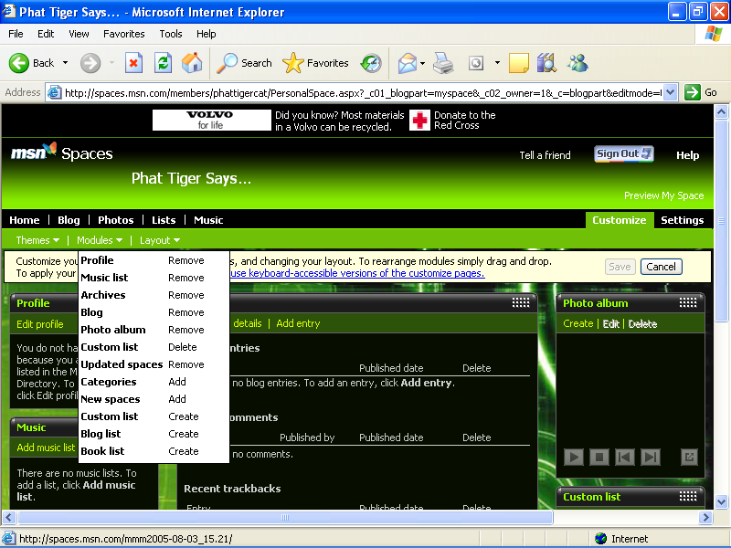The Modules control panel
  - To add a module, click the Modules menu, and then click the module you want to add. For this project, click Custom List – Create.
The main detail to pay attention to here is the module action. For instance, when you want to create a custom list, be sure to click Custom List–Create, not Custom List–Delete. If you click the Delete option, you might end up deleting an existing list instead of creating a new one. The four available actions are Create, Delete, Add, and Remove.
If you’re following along with this walkthrough, a new Custom List module should now appear above your Profile module. Ideally, we want this list to be displayed below your profile. Profile information gives visitors a chance to validate your page; therefore, you should keep it near the top-left corner.
To move the newly created Custom List module, click the module’s title bar area, and drag the module so that it’s positioned below the Profile module.
When you’ve finished creating, deleting, and repositioning modules, click Save. Next it’s time to focus on actual content. The first order of business is to take care of your profile information.

Developing Your Profile
At this point, your theme, modules, and layout are basically set. Of course, you’re free to change any of your customizations at any time. But for our purposes, we’ll imagine that we’re all happy with the current setup, which means it’s time to conjure up some information. One of the first pieces of information you should add is your profile data. As mentioned earlier, profile information is pulled directly from the MSN Member Directory. If you’re just getting started with MSN, your profile is most likely empty. You can create an MSN Member Directory profile from your MSN Space. To do so, follow these steps:
- Click Customize, and then click Edit Profile in the Profile module.
- On the Create Your MSN Nickname page, type a nickname, and then click Save. We entered nightwatch_tiger, but you’ll need to enter a unique name. The MSN Member Directory page is displayed.
- Complete the form by filling in only the areas in which you’d like to provide information. You are not required to supply information for every field, and you can always return to edit your profile. At the bottom of the form, read the code of conduct, and then select the I Accept check box if you agree. In the Home Page box, you might want to enter the Web address of your MSN Space (in the form spaces.msn.com/members/your_space).
- After you’ve filled in all the form fields that you feel like addressing, click Save. Your Member Directory (MD) statistics are displayed. You can use this page to add a picture, specify Member Directory interests, and edit your information. The following figure shows a modified Member Directory page with a picture added (phattigercat.jpg) and 10 MD Category Interests (the maximum allowed) selected.
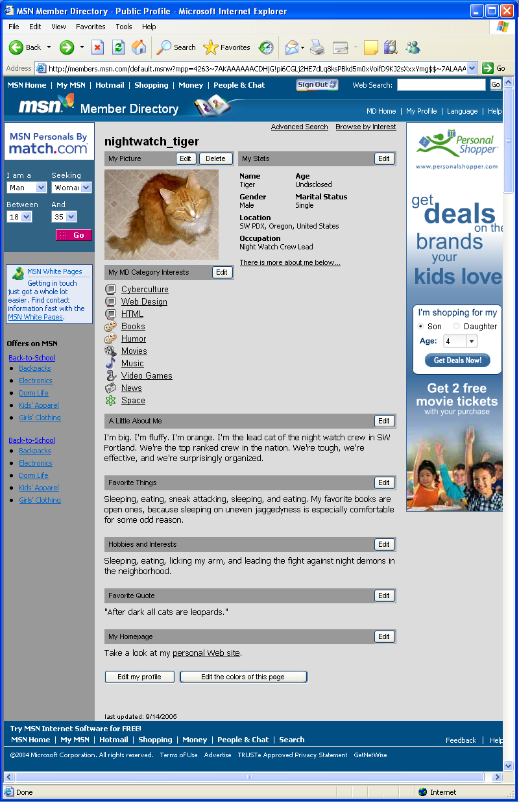
An MSN Member Directory profile
- Close the MSN Member Directory page, and return to your MSN Space. Your profile information should now appear in the Profiles content module. If not, click the Refresh button on your browser’s toolbar. Figure 7-9 shows the Phat Tiger Says… space updated with Phat Tiger’s profile information.
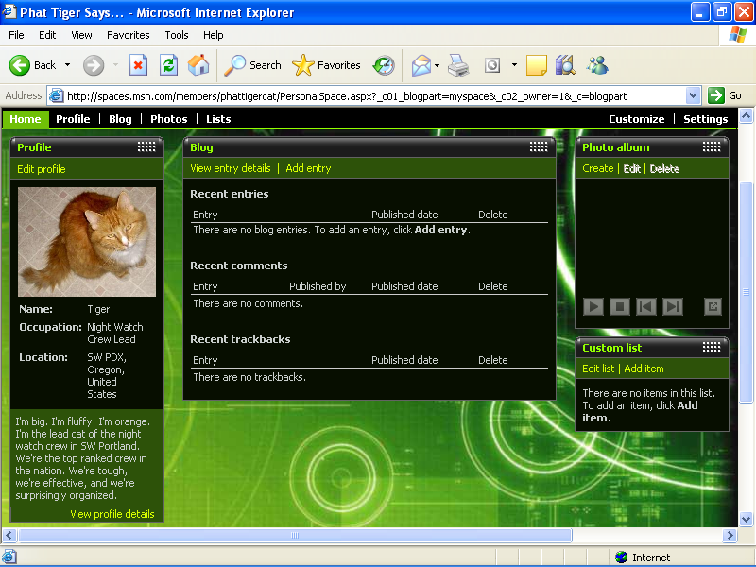
MSN Member Directory profile information in an MSN Space
tip Be patient when making changes to your MSN Member Directory profile. The MSN Member Directory contains millions of profiles, so don’t be alarmed if your computer seems to be reacting a tad slower than normal when you’re updating your profile information.

Composing a Blog Entry
With your profile whipped into shape and presiding over your MSN Space, you’re ready to add content. Let’s start with the most popular content module, the Blog module. The Blog module is where you post entries to your online journal. Adding a blog entry doesn’t take much technical know-how. In fact, the biggest effort lies in actually typing your content. Creating a blog entry requires the following three main steps:
- Open your MSN Space, ensure that you are signed in with your .NET Passport (the Sign In button in the upper-right corner should change to a Sign Out button when you’re signed in), and click the Edit Your Space link below the Sign Out button.
- In the Blog module, click Add Entry. The Edit Blog Entry form is displayed. The date appears by default. Type a title, select a category (if desired), and enter the text of your blog entry. The following figure shows the Edit Blog Entry form with a title, category, and text entered.
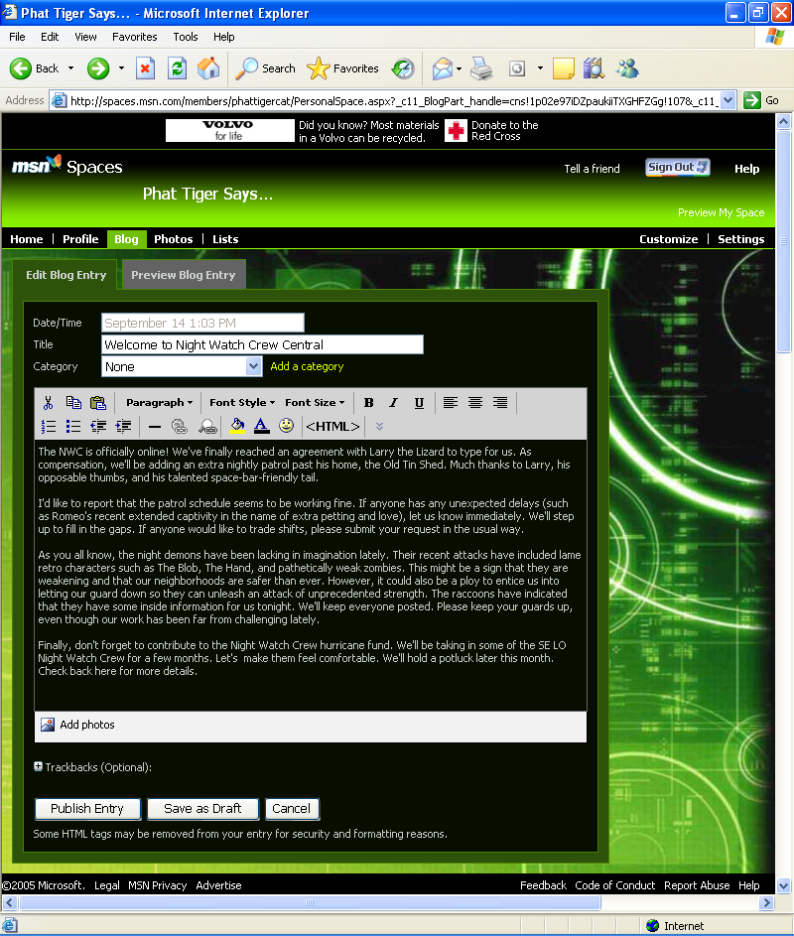
The Edit Blog Entry form

tip Currently, the Edit Blog Entry form doesn’t offer a spelling checker. Therefore, you might want to copy your blog entry’s text into a blank Microsoft Word document before you publish the entry so you can check your spelling and correct your grammar. Also, always click the Preview Blog Entry tab before publishing your text so you can review your words one last time before sending them online.
- Click Publish Entry after you’ve checked your spelling and previewed your text.
After you publish a blog entry, your Blog module shows the entry. To view how your entry appears online, click the Preview My Space link (below the Sign Out button). The following figure shows the Phat Tiger Says… blog entry in Edit Your Space and Preview Your Space views.
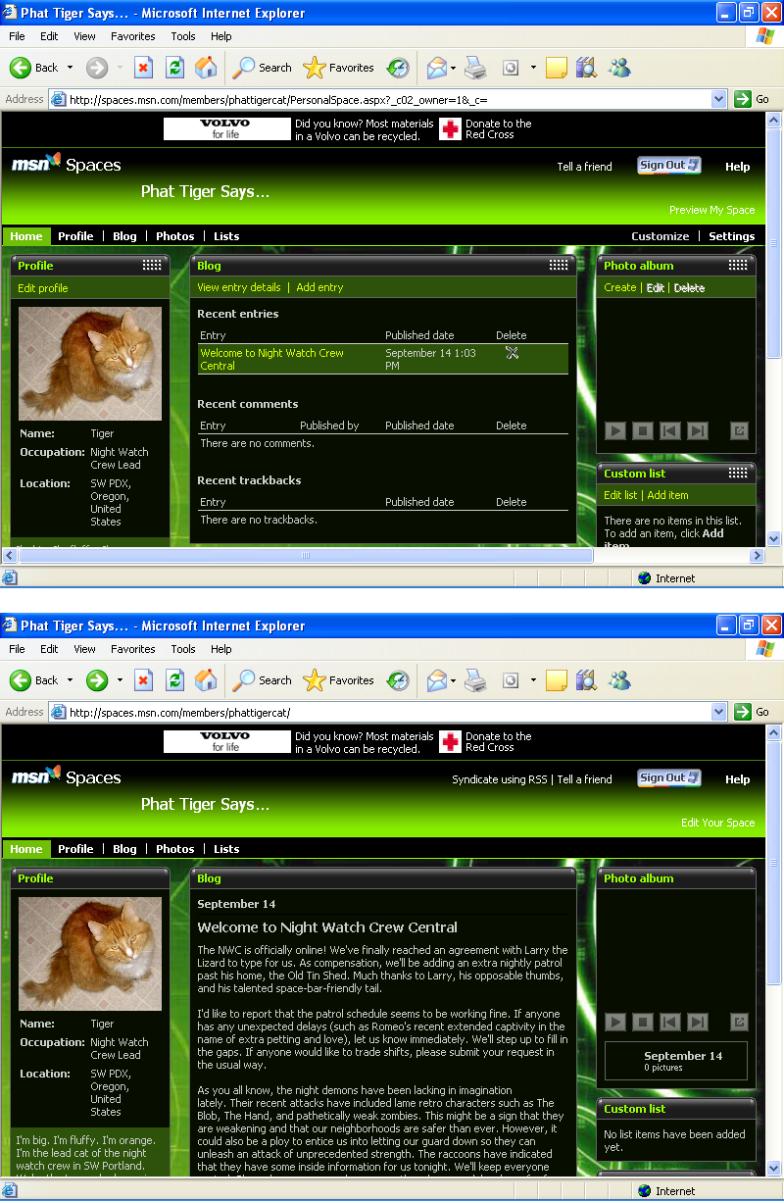
Completed blog entry in editing and preview modes

Creating a Photo Album
In this walkthrough, you’ve configured your profile information and posted a blog entry. The time has come to add some pictures to accompany your words. Here are the steps required to compose a photo album:
- Open your MSN Space in Edit Your Space view (remember to sign in using your .NET Passport if you aren’t already signed in).
- In the Photo Album module, click Create. A New Album page is displayed on the Photos tab.
- Type an album name in the Album Title box, and then click Add Photos. The first time you click Add Photos, you’ll see the Install the MSN Photo Upload Control window. You need to use this photo-uploading tool to create photo albums in your MSN Space. Click Install Now. Depending on your browser settings, you might have to click the Pop-up Blocker bar at the top of your browser window and allow the Microsoft ActiveX photo upload control to be installed.
- In the Photo Upload Control window, navigate to the folder on your computer that contains the photographs you want to upload.
- Click each photograph that you want to upload, as demonstrated in the following figure, which shows six photographs selected for uploading.
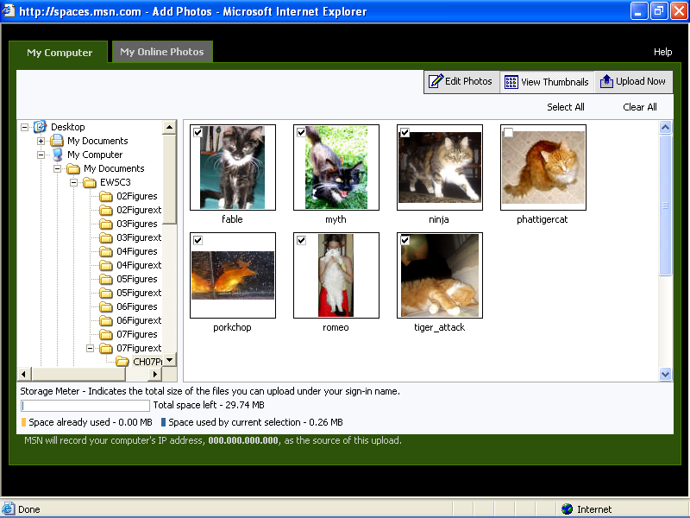
Uploading images from your computer to your MSN Space
- Click the Upload Now button. An Upload Progress message box is displayed while the images are copied from your computer to an MSN Spaces server.
- Click the Save and Close button. In the Photo Album module, click Edit. On the Edit Album page click below a picture, and then type a caption.
note Photo captions are displayed when visitors view your photo albums in full-size view by clicking the Photos tab. Captions do not appear on your home page in the Photo Album content module.
- After you finish adding captions, click Save, and then click Close.
When you create a photo album, your home page displays thumbnails of your most recently added photo album in the Photo Album module. Visitors can view full-size images and read your captions by clicking the Photos link in your MSN Space.

Building Custom Lists
Ahh, lists—who can imagine a world without lists? Lists are the last content tool we cover in this walkthrough. The two lists the Night Watch Crew likes to display in its MSN Space are an Active Members list and a Favorite Links list. You can create any list you want for this exercise, but if you want to use the Night Watch Crew information, you’re free to copy the information from the Phat Tiger Says… space. To create a list, follow these steps:
- In Edit Your Space view, click Edit List in a Custom List module.
- Click Rename List, type a list name, and then click OK.
- Click Add Item, type the list item name in the first text box, add a URL and description if desired, and then click Add.
- Repeat step 3 as needed to add all list items. List items appear in the order in which you type them. After all items have been added, click Home to view your completed list.
The following figure shows the Phat Tiger Says… MSN Space with the Active Members list on the left and a Favorite Links list on the right. You can add and delete lists as you need them, which is one of the beauties of MSN Spaces—creating, deleting, and editing lists in your space is quick and easy.
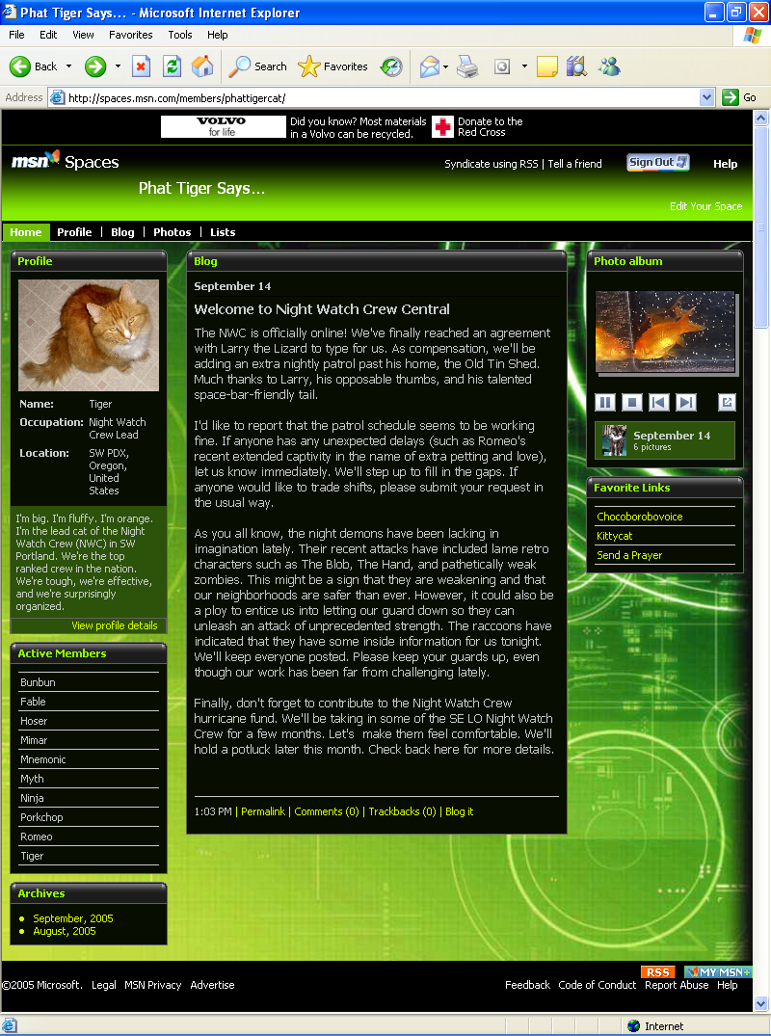
Custom lists

Configuring MSN Space Settings
MSN controls many of the settings associated with your MSN Space, but you do have control over a few settings. To access the settings you can control, open your MSN Space in Edit Your Space view, and click the Settings link. The following figure shows the Space Settings tab on the Settings page
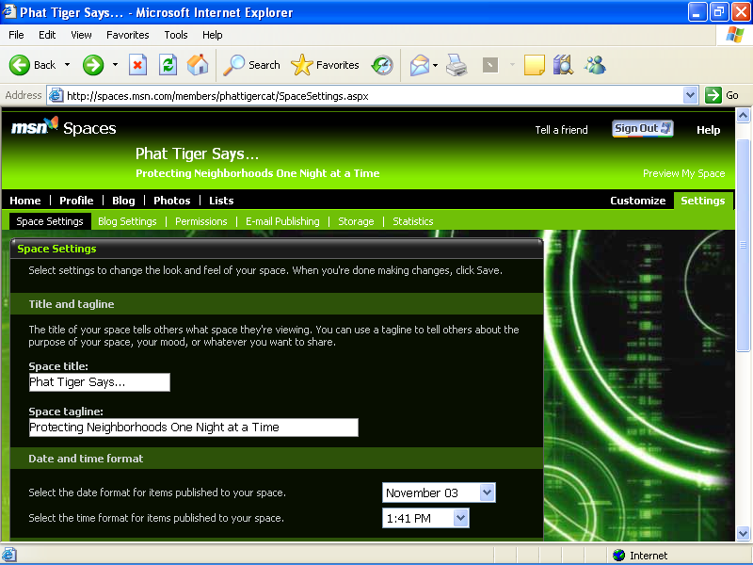
Settings options for MSN Spaces

tip Whenever you make changes to your space’s settings, you must click the Save button to apply your changes.

The following tabs are available:
- Space Settings Allows you to change your MSN Space’s title, tagline, date and time format, time zone, and syndication settings. Keep in mind that to be syndicated, your MSN Space must be configured as a Public space, as defined in the Permissions item in this list. You can also delete your MSN Space by using the Space Settings tab, as described later in the next section.
lingo Syndication refers to a feature that makes your content available to others to use and display on their Web sites (including newsreaders). When you update syndicated content, other sites containing the content are also updated.
- Blog Settings Enables you to specify how many blog entries appear at one time. The default is five entries. Among other settings, you can specify whether visitors can leave comments and whether other MSN Spaces can link to your space or you can link to other spaces. Links to other MSN Spaces are called trackbacks.
lingo A trackback is a notification that’s sent from one blog to another blog as a means to announce that one blog has made a reference to another blog’s entry. By using trackbacks, you can effortlessly alert others about your blog’s content as well as see how many other bloggers are referencing (or not referencing) your blog.
- Permissions Allows you to specify who can view your space. You do this by classifying your MSN Space as Public, Messenger, or Private. A Public space allows everyone on the Web to view it. If a space uses syndication or trackbacks, the space must be a Public space. A Messenger space allows only the people on the space’s associated MSN Messenger list to view the space. A Private space allows only selected people from an MSN Address Book to view the space.
- E-Mail Publishing Lets you configure your MSN Space so that you can upload entries from mobile devices, such as phones or handheld devices, or by using an e-mail application.
- Storage Shows you how much space your images are using and provides a way in which you can easily delete old images. To delete images, simply select the check boxes next to old or unwanted images, and then click the Delete button.
- Statistics Displays visitor statistics, such as the total number of pages viewed, the number of page views during the current week, the number of pages viewed during the current day, and the number of pages viewed within the last hour.
Most likely, you won’t have to visit your Settings options very often, but it’s always a good idea to know what options are available to you. Furthermore, you might want to check back every so often since MSN is a dynamic service. You’ll find new features and options added to MSN’s products on a fairly regular basis if you keep your eyes open.
note To view the finished walkthrough blog, visit spaces.msn.com/members/phattigercat. Feel free to leave a comment for the Night Watch Crew or send a picture for possible inclusion if you stop by.

Deleting: Content, Modules, MSN Spaces
Now that you know how to build an MSN Space, you need to know how to delete content, content modules, and MSN Spaces. Deleting unused content and spaces is a good practice because it helps to conserve MSN server space. (MSN provides and maintains online space for free, so the least we can do is ensure that we don’t waste the space with outdated or unused MSN Spaces.)
To delete content, follow these steps:
- Display your MSN Space in Edit Your Space view.
- Click the Edit link in the content module in which you want to delete the content.
- Manually delete the content.
To delete a content module, follow these steps:
- Display your MSN Space in Edit Your Space view.
- Click Customize.
- Click Modules, and then click the appropriate the command to delete or remove the module of your choice.
To delete your MSN Space, follow these steps:
- Display your MSN Space in Edit Your Space view.
- Click Settings.
- On the Space Settings tab, click Delete My Space, and then click OK.
warning When you delete an MSN Space, the Web address for your space will be unavailable for 60 days. Be sure that you want to delete your entire MSN Space and not just your content.

Expanding Your MSN Space
In this walkthrough, we’ve provided the foundation for you to create an MSN Space. You’ve selected a theme and a layout, added and removed content modules, created a profile, posted a blog entry, built a photo album, compiled lists, and adjusted your settings. Not surprisingly, a number of features exist that we didn’t touch on here. For example, you can create music lists by uploading a Microsoft Windows Media Player playlist, and you can automatically send alerts to your contacts when you update your blog.
You should peruse the MSN Spaces Help and FAQ pages to see what other capabilities you can include in your space. Adding features often requires you to follow procedures similar to those we outline in this walkthrough. At times, you’ll need to fill in forms, download special tools (similar to downloading the MSN Photo Upload Control described earlier in this chapter), and provide various settings. But by this point, you should already be used to all that.

tip You can easily return to your MSN Space by clicking the My MSN Space button in the MSN Messenger window or on the MSN toolbar.
Congratulations on completing Easy Web Design’s Chapter 7 walkthrough. Whenever you’re ready, we’ll meet you in the Chapter 8 walkthrough, where you’ll learn how to hand code and entire Web site using XHTML and CSS!

